Yeo Catchment Strategy – Phase 1

Project Location
Somerset and West Dorset
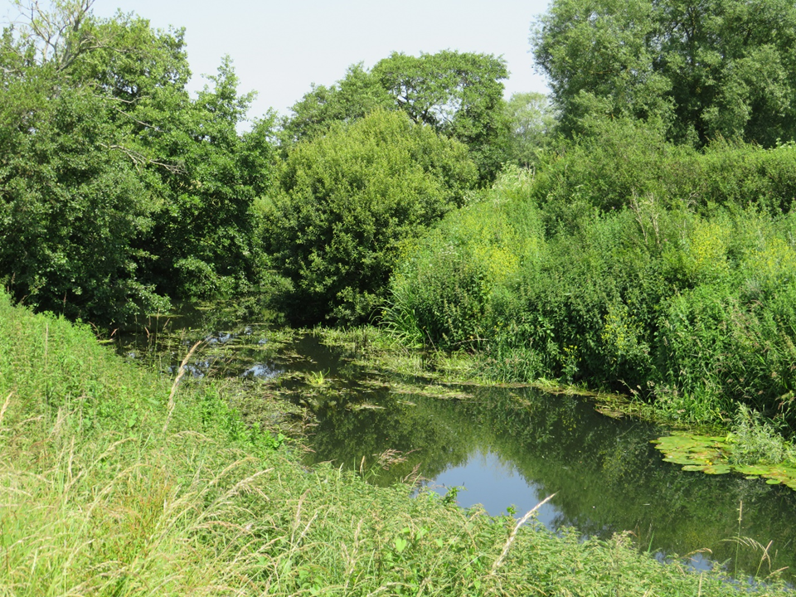
River Yeo, Mudford – a natural and unspoilt reach of the river?
Project Description
The River Yeo is a major tributary of the River Parrett. Much of the catchment is rural with areas of intensive agriculture but there are also two sizeable urban areas, Yeovil and Sherborne, which give rise to a number of urban related impacts, i.e. on-going development, diffuse and point source pollution. The majority of the waterbodies within the catchment are classified as moderate with one, the River Wriggle, classified as poor, and the Yeo D/s Over Compton is designated as a HMWB. Reasons for not achieving good status predominantly arise from phosphate impacts from agriculture and the water industry with surface water impacts arising from physical modification, industry, transport, urbanisation and other activities being significant in the Yeo D/s Over Compton waterbody. The catchment should achieve good or potentially good ecological and chemical status.
The project is needed to address the WFD failures identified above but also to mitigate catchment wide pressures and impacts. The project will be designed to align with the goals and objectives of stakeholders, e.g. Somerset Catchment Partnership, Environment Agency, Somerset County Council, Natural England, parish councils, private landowners, conservation organisations as well as the wider community. Increasing resilience to climate change and ecological decline within the context of the emergency declared by local authorities and in alignment with the Governments 25 Year Plan are major aims of the project. The key goals within the 25 Year Plan which the Catchment Strategy will help to achieve are:

- Clean and plentiful water
- Thriving plants and wildlife
- A reduced risk of harm from environmental hazards, i.e. flooding
- Enhanced beauty, heritage and engagement with the natural environment

The project is designed to be delivered in phases with this first phase focused on obtaining baseline data for the catchment through desk top assessment and extensive field surveys and data collection (e.g. water sampling). The information obtained will enable the identification of key catchment pressures and impacts which will be analysed to prioritise and outline design measures for rehabilitation, mitigation and enhancement to address the identified impacts. The project is seeking to improve the catchment by implementing actions which will promote the restoration of natural river processes, improve connectivity for fish and other animals, provide diversified habitats and enhance biodiversity. In aggregate these actions will provide a basis for improvements in water quality through phytoremediation, enhanced flow regimes, etc. SMART objectives will be designed and an evaluation, monitoring and management programme will be prepared for the highest priority measures. A major element throughout the phase is establishing and developing landowner and stakeholder engagement which will include engaging with and seeking the involvement of the wider community, including schools, organisations such as Guides and Scouts, Community Associations, special interest groups, e.g. angling groups, as well as businesses, e.g. Wessex Water. Yeovil Rivers Community Trust will work with existing partners (e.g. Environment Agency, Farming and Wildlife Advisory Group (SW), Somerset Catchment Partnership, Somerset Rivers Authority, Wild Trout Trust, Wessex Water and South Somerset District Council) to collate any existing information.

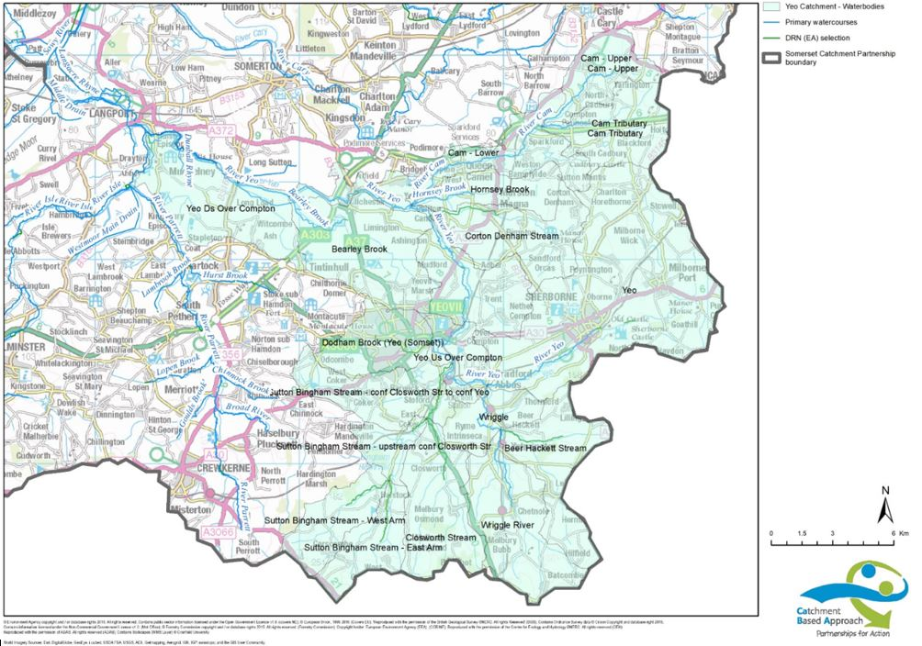
Location of the Yeo Catchment

Main Features and Benefits
This first phase will lay the foundations for implementation of restoration, mitigation and enhancement measures across the catchment over a period of several years. Major benefits will include: Improved attenuation of surface water flooding both at known “hotspots” and in aggregate within the urban portions of the catchment;
- Enhanced resilience to climate change and flood risk management, i.e. via promoting natural processes and flood management and promoting new sustainable techniques in land and water management;
- Enhanced aesthetic and recreational value of the locality through the creation of better quality green and blue infrastructure, i.e. creation of new aquatic and terrestrial habitats as part of scheme and enhanced public open spaces;
- Increased involvement and empowerment of community and landowners in shaping and maintaining their locality through the Yeovil Rivers Community Trust (YRCT) and encouraging local groups to form their own charities/Friends Groups.
- Raising public awareness and understanding of aquatic habitats, flooding, pollution, water scarcity and conservation and increasing resilience in communities to water related emergencies;
- Reconnecting people with the river, improving access and promoting activities which celebrate the river from different perspectives (social, artistic, scientific, etc.), encouraging citizen science and popular involvement in implementing restoration, monitoring and evaluation actions. There is the potential to use the project in an educational role for wider public and social benefits.
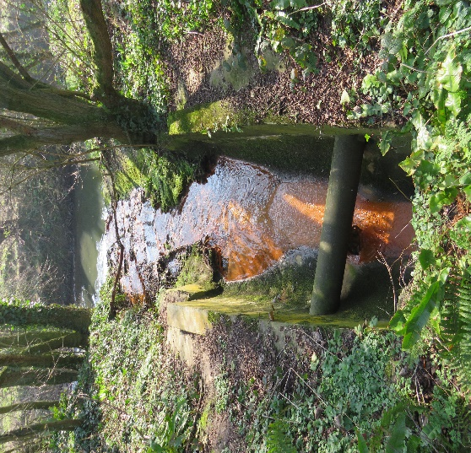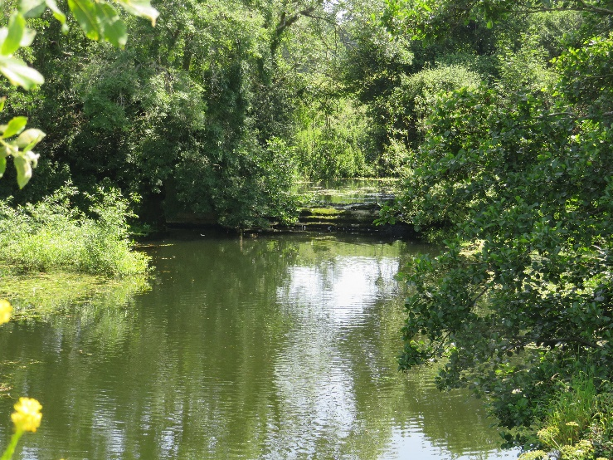
An example of poor water quality impact. Weirs – disrupt connectivity for wildlife.
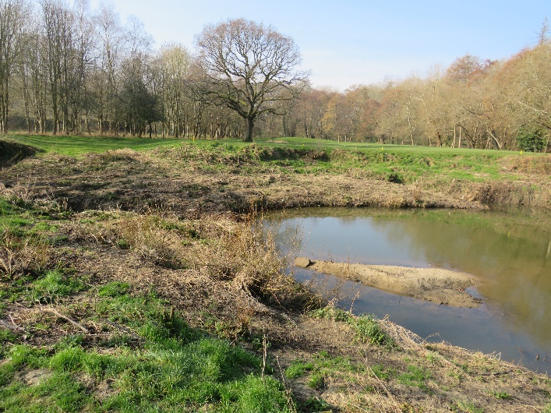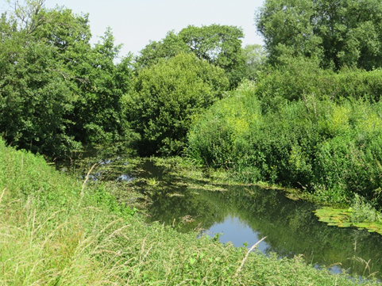
Low flows and sedimentation fill in pools. High quality river habitat – we want more of this!

Project Timetable

It is hoped the phase will commence in May/June 2020 with extensive data collection from stakeholders, engagement, desk top analysis and walkover surveys carried out In June – September 2020 and 2021 if necessary. Pressures and impacts will then be identified and a plan prepared, with cost/benefit details and mitigation/restoration/enhancement proposals prioritised. The strategy will hopefully be completed by December 2021 and subject to funding, Phase 2 will aim to commence delivery of measures in 2022-2023.

Stakeholder and community consultation and engagement are fundamental to the entire project and will continue throughout the implementation phases and beyond!

Want to get more involved?

YRCT welcomes the involvement of all members of the community in all our activities.

If you would welcome the chance to make improvements to our environment and the community by supporting our work through volunteering or are thinking of becoming a trustee please do contact us.

Email: lorne.thomson@yrct.net
Facebook: Yeovil Rivers Community Trust
Address: 19 Chilton Grove, Yeovil, Somerset, BA21 4AN
Registered Charity Number: 1180724

