Yeovil Rivers Community Trust receives grant of £193,600 from the Government’s Green Recovery Challenge Fund

- The Dodham Brook Restoration Project aims to rehabilitate a heavily modified urban water body in Yeovil, Somerset. Phase 3 focuses on works in the concrete flood channel that poses the most significant barrier to connectivity for wildlife.
- 90 projects awarded grants to accelerate the implementation of nature-based projects, from new ‘insect pathways’ in our countryside and towns, to tree planting projects in deprived urban areas
- Second funding round of Green Recovery Challenge Fund backed by £40 million, with over 1,000 jobs to be created or retained in England
Yeovil Rivers Community Trust, Dodham Brook Restoration Project (Phase 3) has been awarded a grant from the Government’s £40 million second round of the Green Recovery Challenge Fund, a multi-million pound boost for green jobs and nature recovery

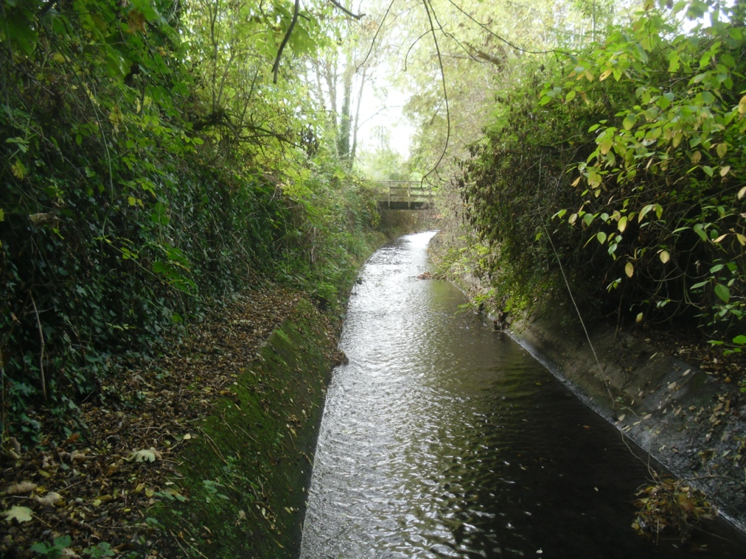
Flood channel at the focus of the Dodham Brook Restoration Project, phase 3
Ninety nature projects across England have been awarded grants from £68,100 to £1,950,000 to create and retain over 1,000 green jobs, backed by the Government’s £80 million Green Recovery Challenge Fund.
Work will be carried out on over 600 sites from North Northumberland to the tip of Cornwall, and combined with the first round, almost a million trees will be planted, contributing towards the Government’s commitment to treble tree planting rates across England by the end of this Parliament.
The project will deliver measures to restore connectivity to the River Yeo and areas upstream of the concrete channel by installing features that would create islands of new habitat in the channel. The features are designed to reduce water velocities, increase water depth and provide multiple types of habitats, which will provide new homes for plants and animals and facilitate enhanced passage by animals including fish and insects between the Yeo and Dodham Brook. Connectivity will be further improved by the installation of a fish pass and eel tiles. Biodiversity will be significantly increased by planting a diverse range of aquatic plants to help mitigate the effects of climate change.

In addition, extensive interpretation would be established to inform the public about the restoration features, the benefits they are intended to produce, how this helps adaptation to climate change and reconnect people with the watercourse and aquatic environments in general. People will be encouraged to engage in various events and activities to educate and enthuse them in all aspects of our water heritage.

Lorne Thomson, Trustee and Chair of the Yeovil Rivers Community Trust, said:
“We are delighted to have received this very generous grant which will enable the Yeovil Rivers Community Trust and our partners, especially SSDC, to undertake this project phase. Rehabilitating heavily modified urban watercourses such as the Dodham Brook is challenging but is vital in our efforts to combat the negative impacts of ecological decline and climate change. The Green Recovery Challenge Fund grant will allow us to transform the existing channel for the benefit of wildlife, people and the wider environment”.
The Green Recovery Challenge Fund is a key part of the Prime Minister’s 10 Point Plan to kick-start nature recovery and tackle climate change. Connecting people with nature is another priority theme: by increasing access to nature and greenspaces, projects will support both physical and mental wellbeing. The Government's Green Recovery Challenge Fund was developed by Defra and its Arm's-Length Bodies The fund is being delivered by The National Lottery Heritage Fund in partnership with Natural England, the Environment Agency and Forestry Commission.

Environment Minister, Rebecca Pow, said:
“The diverse and ambitious projects being awarded funding today will help environmental organisations employ more people to work on tree-planting, nature restoration and crucially, help more of the public to access and enjoy the outdoors.
“Through our £80 million Fund, we are on track to support over 2,500 jobs, plant almost a million trees and increase nature recovery at a huge scale across the country, which will help us deliver against our 25 Year Environment Plan.”
Ros Kerslake, Chief Executive, National Lottery Heritage Fund, said:
“From wetland restoration, to creating wildlife-rich habitat for bees, it is vital that we value, protect and rebuild our natural heritage. This new funding will not only allow projects to carry out direct conservation which is essential in protecting our biodiversity, but it will increase awareness of how and why we need to change our behaviours in order to protect our future.”
Emma Howard Boyd, Chair of the Environment Agency, said:
“By supporting jobs from Northumberland to Somerset, the Green Recovery Challenge Fund will help deliver a nature positive future. The fund supports young people to develop skills needed to protect nature, build back greener and prepare for climate impacts, like floods and heatwaves.”
Natural England Chair Tony Juniper said:
“Our environmental and conservation charity sector does an incredible job in protecting, improving and restoring the natural environment for the benefit of communities and the economy.”
Forestry Commission Chair Sir William Worsley said:
“This funding will help deliver thousands more trees and help us achieve our target of trebling tree planting rates in England by the end of the Parliament. We need to work towards net zero emissions by 2050; to address biodiversity loss; to better connect people with nature; and to create more green jobs in doing so. Trees are central to this and the projects being awarded these grants will have a hugely important role in helping us realise these objectives.”
A full list of awards is available to view at: https://www.heritagefund.org.uk/publications/green-recovery-challenge-fund-second-round-decisions-july-2021
ENDS
Notes to editors
The Government's Green Recovery Challenge Fund was developed by Defra and its Arm's-Length Bodies. It is being delivered by The National Lottery Heritage Fund in partnership with Natural England, the Environment Agency and Forestry Commission.’
About The National Lottery Heritage Fund
Using money raised by the National Lottery, we Inspire, lead and resource the UK’s heritage to create positive and lasting change for people and communities, now and in the future. www.heritagefund.org.uk

